|  |  |
| --- | --- |
|  | Project – Question 2 |
|  |  |
|  | Christina Tatang 30003663  Programming III |

Contents

Introduction 2

Purpose 2

Document Conventions 2

Intended Audience and Reading Suggestions 2

Project Scope 2

References 2

Overall Description 2

Product Perspective 2

Product Features 2

User Classes and Characteristics 3

Operating Environment 3

Design and Implementation Constraints 3

Assumptions and Dependencies 3

System Features and Requirements 3

Functional Requirements 3

External Interface Requirements 4

User Interfaces 4

Hardware Interfaces 4

Software Interfaces 4

Communication Interfaces 4

Non-functional Requirements 4

Software Requirement Specification Approval 4

# Introduction

## Purpose

This documents describes the requirements specification (SRS) for the music player application that include a user log in to access the application.

## Document Conventions

|  |  |
| --- | --- |
| ER | Entity Relationship |
| RAM | Random Access Memory |
| MySQL | A relational database management system based on SQL – Structured Query Language |
| TCP/IP | Transmission Control Protocol/Internet Protocol |
| GUI | Graphical User Interface |

## Intended Audience and Reading Suggestions

This project is written for college assignment purpose, thus this documents intended for college lecturer and the people that involved in making this application.

## Project Scope

The purpose of the music player application is complete the assignment that is given by college lecturer. This application can also be used as a music player application to play, search, and delete from the playlist. The system will also have a log in form that will store username and password before the user can access the music player form. With this application, I hope I can bring a more comfortable and convenient application to run a music player application.

## References

<https://krazytech.com/projects/sample-software-requirements-specificationsrs-report-airline-database>

<https://www.perforce.com/blog/alm/how-write-software-requirements-specification-srs-document>

# Overall Description

## Product Perspective

The application will store information about user details and song details. The user details includes the just the username and password to log in to music player form and the song details includes the song name and the path to get the song from the folder device.

## Product Features

The user will be able to log in to application or create a new login detail. Once the user already log in, the music player form will show and the user will be able to add song, play current song, play the first song, play the previous song, play the next song, play the last song in the playlist. The user will also be able to search for a song and delete the song.

The features as shown in entity-relationship model (ER model)

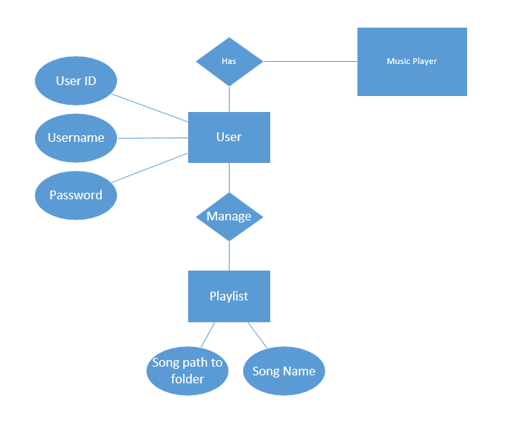

## User Classes and Characteristics

The users should be able to log in with username and password that will show the music player form. If the user doesn’t log in details, the user can create a new one with enter username the user wanted and password. In the music player form, the user should be able to add songs, search a song, and delete a certain song in the playlist. The user can play the first song, previous song, current song, next song, and last song. This music player should also be automatically sort the song when displaying it in the form.

## Operating Environment

Operating environment for the music player is listed below.

* Database: MySQL database
* Development Platform : Visual Studio .net
* Operating system: Windows 7 or higher.
* Hardware: 1.8 GHz or faster processor and 2 GB of RAM.

## Design and Implementation Constraints

The other constraints of this application is the application required database. So the user need access to the MySQL database and import the information.

## Assumptions and Dependencies

It is assumed the user enter the correct username or not using the same username to create new log in detail, the music player form will be shown. It is assumed that the user is unfamiliar with how the application work so that we put a help and about menu strip to become a help guide for the user.

# System Features and Requirements

## Functional Requirements

* The system must be able to store account that contain details about username and password and put it in the MySQL database.
* The system must be able to play song (play first, previous, next, and last).
* The system must be able to add new song and sort it in the playlist.
* The system must have log in form or create new account form to access the music player form.
* The system must be able search for a song from playlist.
* The system must be able to delete a song from playlist.

## External Interface Requirements

### User Interfaces

* All user have individual and secure log on that have their username and password and must be able to log in to the music player form.
* Create a help button that gives information about how to use the application and about button that provide information about the overview of the application.
* Layout standards to facilitate software localization

### Hardware Interfaces

The system should run on the device that have the access to MySQL database and should run on operating system includes Windows and MacOS.

### Software Interfaces

This are the software used for the music player application.

* I choose Windows for the operating system for its best support and user-friendliness
* I choose MySQL for the database to make it more convenience and easier to store the information
* I choose Visual Studio to implement my music player project.

### Communication Interfaces

This application required TCP/IP type of communications interface to run the database. This communication protocols used to interconnect network devices on the internet and can also be used as a communications protocol in a private network (an intranet or an extranet)

## Non-functional Requirements

* The application can run efficient and effective.
* The speed of the application while running
* The application can store unlimited data (large capacity for user and song)

# Software Requirement Specification Approval

|  |  |  |  |
| --- | --- | --- | --- |
| Signature: |  | Date: |  |
| Print Name: |  |  |  |
| Title: |  |  |  |
| Role: |  |  |  |